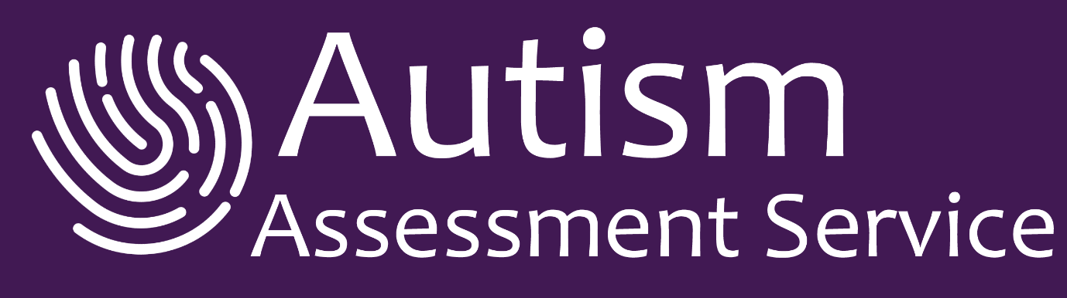

COVID-19 Patient Safety Policy
​
We at Autism Assessment Service are fully committed to following the UK government guidance and will always adhere to the current recommendations to keep you, your child, our staff and associates safe during this difficult and fast changing time.
To minimise the risk of transmission of COVID-19 we have adopted the following protocols:
​
- Remote Consultations
​
Through experience, we know that it is possible for us to undertake certain parts of our service via video link. Examples of such appointments might include:
​
- Initial appointment with parent / carer
- Certain clinical assessments
- Report and feedback session
​
It may be possible or necessary for more than one member of the household to contribute to these meetings. The details will be discussed with you prior to any appointment.

​
- Face-to-face consultation process
​
When a remote appointment is not possible the reasons for this will be explained to you.
Patient safety is our priority so all face-to-face consultations are conducted in accordance with the latest Public Health England Guidance.

2.1 Screening questionnaire:
Prior to any face-to-face contact, we will ask you to complete a COIVID-19 screening questionnaire. This is to identify if you or anyone in your household or support bubble has any symptoms associated with COVID-19.
​
In addition, we would ask if anyone attending the appointment has been in contact with someone with any COVID -19 symptoms in the last 14 days, or who has a confirmed diagnosis of COVID-19 in the last 14 days.
​
If the answer to any of the above is yes our clinician will review the situation. This may mean rescheduling your face-to-face appointment to another time to keep everyone safe.

​

2.2 The appointment
​Face-to-face appointments are reserved for essential medical assessment that cannot be completed using remote/ virtual platforms. We ask you to help us maintain 2 metre social distancing as is currently advised.

During face-to-face consultations, our clinicians will follow the PPE guidance below:
- Wear face masks at all times
- Use hand sanitizer regularly
- All rooms will be well ventilated
- Change their outer clothing between sessions
- Clean all equipment and contact areas in between each session

Any adults attending the appointment will also be asked to wear a face mask (unless you are exempt) and to sanitize their hands regularly.

Our Clinicians are practised at explaining the reasons for PPE to young people to avoid concern or anxiety. For further detail please see https://www.gov.uk/government/collections/coronavirus-covid-19-personal-protective-equipment-ppe

For patient safety we request that all face-to-face appointments are kept to time. We ask you to arrive no earlier than 5 minutes prior to your scheduled appointment, unless requested to do so.

There will be an opportunity to follow up on matters that you were unable to discuss during your face-to-face time with the clinician after the clinic session, if you wish to do so. Your clinician will facilitate this at your request.

In the interest of safety, we are offering staggered appointments with clinicians. This is to reduce the risk of overlap of times between patients.
​
2.3 The attendees
We ask for your cooperation in that only one parent / carer should attend the appointment, if accompanying the patient.

For some appointments we use a multidisciplinary mode of assessment, which involves two clinicians. The additional clinician may attend in person or may join remotely via video link. The details will be agreed with you prior to the appointment.

All our clinicians complete Lateral flow tests twice weekly and have temperature checks daily. This is for the safety of patients, parents/carers and our clinicians.

See Government guidance on meeting others safely
https://www.gov.uk/government/publications/coronavirus-covid-19-meeting-with-others-safely-social-distancing/coronavirus-covid-19-meeting-with-others-safely-social-distancing
​
We would like to thank you in advance for your flexibility and cooperation whilst we all work our way through these unprecedented times.

This policy will be reviewed in line with Public Health England guidelines

